Western Bat Programmatic Biological Opinion (PBO) and Programmatic Conference Opinion (PCO) for the following bat species: Indiana bat (Myotis sodalis, MYSO), gray bat (M. grisescens, MYGR), northern long-eared bat (M. septentrionalis, MYSE), tricolored bat (Perimyotis subflavus, PESU), and little brown bat (M. lucifugus, MYLU)
link to Programmatic Biological Opinion https://connect.ncdot.gov/resources/Environmental/EAU/BSG/Documents/Bats/Bat%20Programmatic%20(Div%209-14)/WNC%20Bats%20PBO%20Div%209-14%20(2025).pdf

For NRTR Documentation for projects in Divisions 9-14, we typically do not produce a BC at this time not knowing what construction activities will occur. It is our protocol to show a BC of Unresolved until we get closer to project permitting and can determine impacts and develop a biological conclusion for listed animal species. The blurb below is appropriate for this stage of project planning.

Biological Conclusion: Unresolved
As of [Date], the following federally protected bat species are listed in IPaC (https://ecos.fws.gov/ipac/) as occurring in the action area: [list of species in IPaC]. Construction activities for this project are unknown at this stage in project planning, NCDOT will resolve Section 7 prior to let as appropriate.

To be included in NEPA/SEPA Documentation for projects in Divisions 9-14.
The U.S. Fish and Wildlife Service (USFWS), in partnership with the Federal Highway Administration (FHWA), U.S. Army Corps of Engineers (USACE), and NCDOT, has issued a combined Programmatic Biological Opinion (PBO) and Programmatic Conference Opinion (PCO) for the following bat species: Indiana bat (Myotis sodalis, MYSO), gray bat (M. grisescens, MYGR), northern long-eared bat (M. septentrionalis, MYSE), tricolored bat (Perimyotis subflavus, PESU), and little brown bat (M. lucifugus, MYLU). Per current design and construction plans, the project is eligible for PBO use and NCDOT can adhere to the appropriate CMs. The proposed biological conclusion for bats is [BSG will determine this using pg. 33 of PBO Table 5 to determine effect for project - pasted below]. The PBO will ensure compliance with Section 7 of the Endangered Species Act for five years (effective through April 1, 2030) for all NCDOT projects with a federal nexus in Divisions 9-14, which includes [XXXX County] , where [PROJECT #] is located.

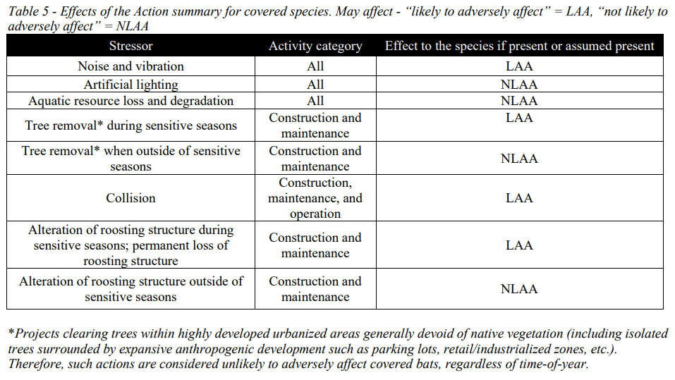

PROCESS FOR USING western bat PBO:
ECAP or Division Environmental Staff will provide the following information to BSG

As of April 2025, BSG is has created a map of the protective buffer areas and is streamlining this process into an interactive online map and online submission form. But in the meantime, if you have a project you would like to use the western bat PBO, please fill in the information below and email it back to clknepp@ncdot.gov so BSG can track all projects used in PBO and then submit them to USFWS.

Project-Level Pre Notification
NCDOT Biological Surveys Group will monitor project implementation to ensure all identified conservation measures are implemented, ensure the appropriateness of the opinion’s application, and track take. For each project conducted under this PBO, the NCDOT project manager will work with their project’s environmental lead to provide BSG with the following information prior to any ground-disturbing actions:

- Description (include lat/long and project timeline and specifics of any structure work that will occur -bridge rehab, culvert extension, # of structures this work will occur on):
- Create a project in IPaC including project boundary and make the following people members: clknepp@ncdot.gov, cdmanley@ncdot.gov, mrmiller2@ncdot.gov, holland_youngman@fws.gov, mark_endries@fws.gov
- Lead Federal Agency: FHWA or USACE
- IPaC generated bat species:
- IPaC generated list date:
- Tree clearing estimate (acres):
- Tree clearing period (months range, if known, example November 2025-May 2026):
- Structure work known (rehabilitation, structure removal or NA and how many structures):
- Structure work period (months range, if known, example November 2025-May 2026):
- Will the project have effects to other listed species that requires consultation that will be addressed separately? Yes/No (list spp)
- Can all pertinent CMs be adhered to, see PBO User Key link below, (you may be able to ignore ‘buffer’ CMs if you are not within a Protective Buffer area): Yes/No
- https://connect.ncdot.gov/resources/Environmental/EAU/BSG/Documents/Bats/Bat%20Programmatic%20(Div%209-14)/WNC%20Bats%20PBO%20User%20Key.pdf
- Findings of any bat survey work conducted in relation to the covered project, including documents such as completed structure survey forms, photographs, etc. (BSG should have this if everything was turned in to us to enter in the database)

